**How Can Local SEO Boost Your Local Business?**

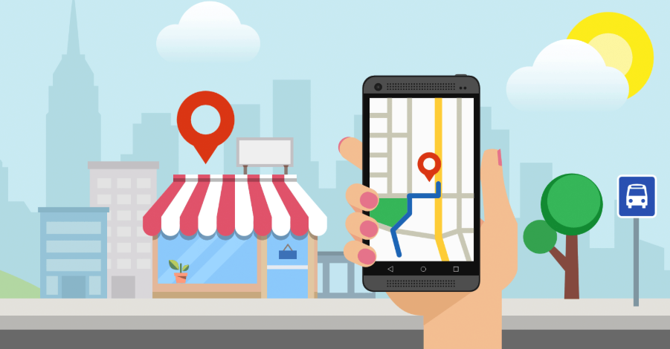

Local SEO is an essential marketing strategy if you're a brick-and-mortar company with services or products of a local nature. If your clients are all local, then you should prefer local SEO to vanilla SEO. Local SEO is a myriad of techniques that are used by website owners to compete for highest rankings for local searches in their area of business for specific keywords related to their products and services.

For e.g. If you're a doctor in a city, your customer demographic will entail mostly people from your city and not from the country as a whole. Google, with its launch of Local SEO algorithms has made it abundantly clear that local business have a special place and it is not in international SEO. They must divert their efforts to focus on local SEO instead.

[**Local SEO**](https://localmybiz.com/) can turn the tables for any local business. If you're looking to build a huge customer base, you must find a reputable local SEO firm that can handle your business needs. When your website pops out in results for other cities, those results are practically wasted because these visitors won't convert to actual sales after all. It is the local clients you want, and this new trend could help you easily capitalize and build a better clientele.

If you're a small business, Local SEO works better for you, rather than multinationals. It will definitely increase the popularity of your business, get you customer reviews and feedback for free and help new prospects locate you easily. When you initially start local SEO, your primary focus must be less used keywords which are longer, commonly known as long-tail keywords in the industry. These keywords can be easily ranked for and will start bringing you a trickle of traffic easily without much effort. Once you've got these out of the way, you can focus on more lucrative, harder to rank keywords. While these will take time and effort, the wait is usually well rewarded with leads and sales.

For local SEO to work out as you intend, your website must be optimized to the hilt for Google to understand where you are located and the nature and extent of services you offer. The local component of your business, which is the city or locality must be present in either the domain name, the website title or the content and if possible, in all of them. This ensures maximum visibility. If you hire a local SEO firm to be sure to talk it over to understand their goals for your business and the efforts their willing to put in. Quite a few campaigns disappear into the dark without any sales or leads just because there was no plan of execution.

Another important factor is the main keyword, which can be included in the business name for online marketing purposes. While the name may sound generic, it will give you a better head start than most of your competitors have had and will get you leads and sales faster than anyone else. For example, if you're a bakery in a city named Bartholomew, you could have your online business name as Bartholomew Bakery ending with the city name. The name sounds generic but will help you greatly as you expand your local SEO efforts. This is a powerful, ingenious SEO strategy that is overlooked mostly and can be your secret weapon to monopolize your rankings in your city.

Your website can also do well by having your name, address and phone number, NAP as we call it in the industry on every page, placed conveniently at a place easily visible to your clients. This is valuable, both from an SEO point of view and from the clients. Your client must not have to fidget about on the website to find a way to contact you and Google must at all times be referenced to your physical address and number so that it knows whom to related the contents of the page to. The best place for this information is in the header or the footer, the former being preferable. Your address helps create trust with the user. How many times have you seen an office address is prominently displayed on every page of the website? This is something that user need and if you deliver, it helps them believe you. If you're willing to take a step further, you can also have Google Maps placed with your location in it which furthers your cause and helps your prospects easily find your location.